CRICKSTATS – SALESFORCE CAPSTONE PROJECT
PHASE 5 – PROJECT DEVELOPMENT
CRICKET PLAYER PERFORMANCE TRACKING APPLICATION
Information | Details
Project Title | CRICKET PLAYER PERFORMANCE TRACKING APPLICATION  CRICKSTATS
Project Domain | Cloud Computing / Salesforce Administration
Platform | Salesforce Lightning Developer Edition
Team Leader | Saravanan S - (Reg. No. 24134031802521044)
Member 2 | SRIVARSHAN S- (Reg. No. 24134031802521048)
Member 3 | Tamilselvan S- (Reg. No. 24134031802521051)
Member 4 | Karthi Karthi- (Reg. No. 24134031802521020)
Member 5 | Barathiraja R- (Reg. No. 24134031802521013)
Institution | PS PT MGR GOVERNMENT ARTS & SCIENCE COLLEGE, SIRKALI, PUTHUR-609108 (College Code: ANM403)
Submission Portal | SkillWallet / Naan Mudhalvan

1. Development Flow
- Milestone 1 – Creation of developer account
- Milestone 2 – Object Creation
- Milestone 3 – Tabs
- Milestone 4 – The Lightning App
- Milestone 5 – Fields & Relationships
- Milestone 6 – Roll-up Summary
- Milestone 7 – Flows

2. Milestone 1 – Salesforce Developer Account
Create a Salesforce Developer Edition account, verify the account through email, set the password/security question and access the Salesforce Setup page.

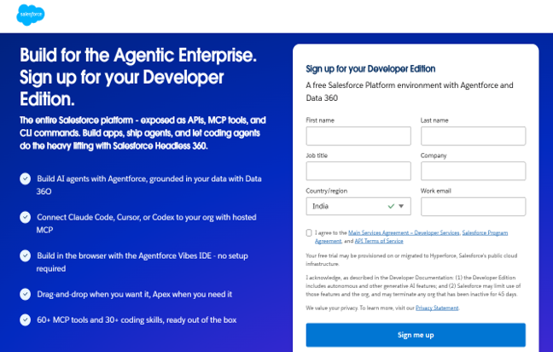

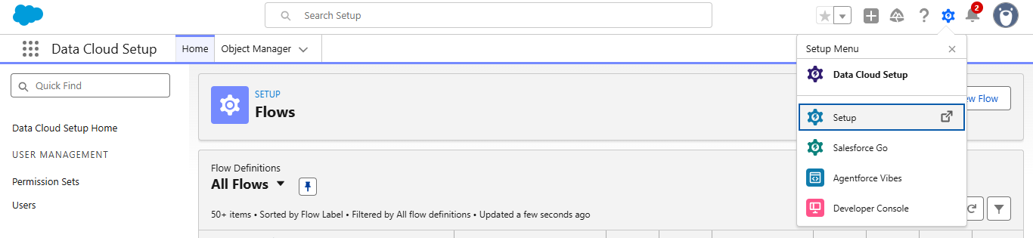

3. Milestone 2 – Object Creation
Create the Player and Match Performance custom objects. Enable reporting, activities, field history and search as described in the reference.
Object | Purpose
Player | Stores player profile and performance summary information.
Match Performance | Stores match-by-match player performance information.

4. Milestone 3 – Custom Tabs
Create custom tabs for Player and Match Performance and make them available to users.

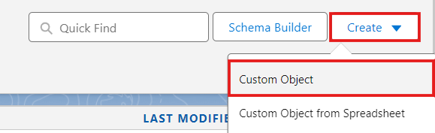

5. Milestone 4 – Custom Tabs Configuration
- Created custom object tabs and appended them to user profiles:
- Players Tab: Tab Style: Trophy / Customized Icon.
- Match Performances Tab: Tab Style: Form / Ball Icon.

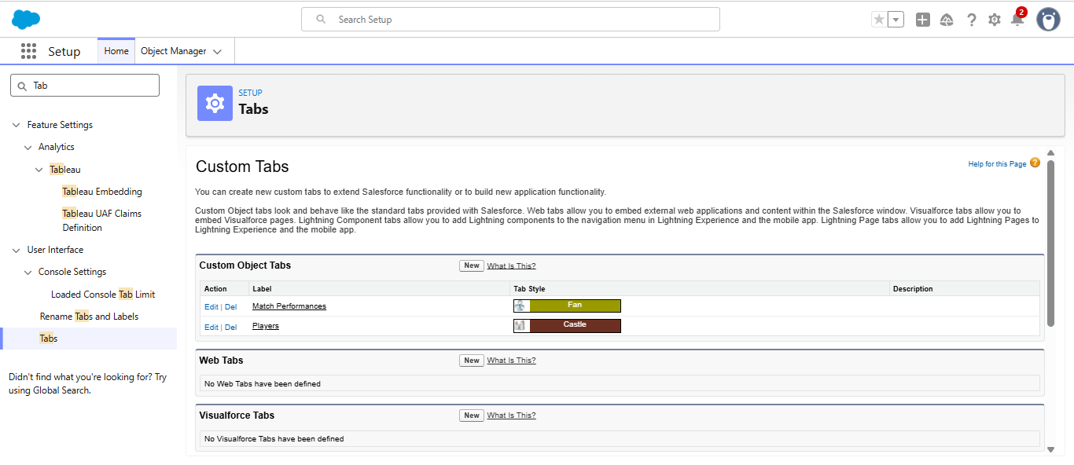

6. Milestone 5 – Lightning App
Create the CRICKSTATS Lightning App with Standard Navigation and add Players, Match Performances, Reports and Dashboards. Assign System Administrator access.

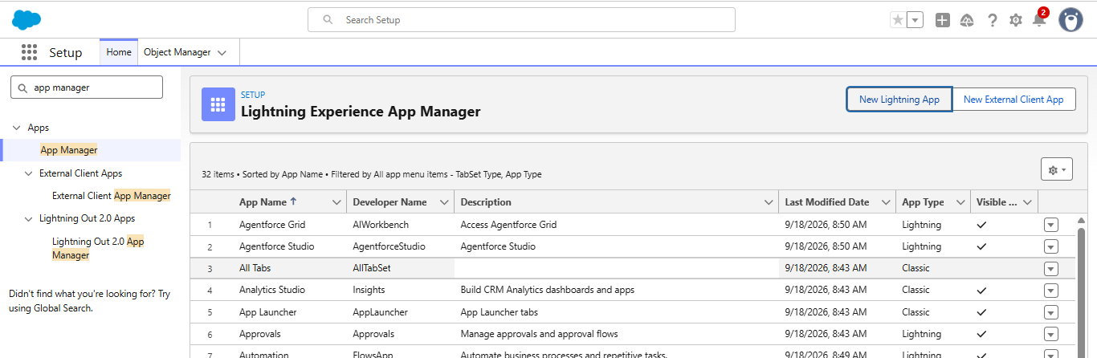

7. Milestone 6 – Fields & Relationships
Player fields include Player Name, Player Number, Profile Picture, Date of Birth, Role, Batting Style, Bowling Style, Nationality, Team and AVG Score. Match Performance fields include Match Performance Name, Player of the Match, Match Result, Runs Scored, Balls Faced, Fours, Sixes, Overs Bowled, Wickets Taken, Runs Conceded, Maiden Overs, Stumpings and Catches, plus the Player master-detail relationship.
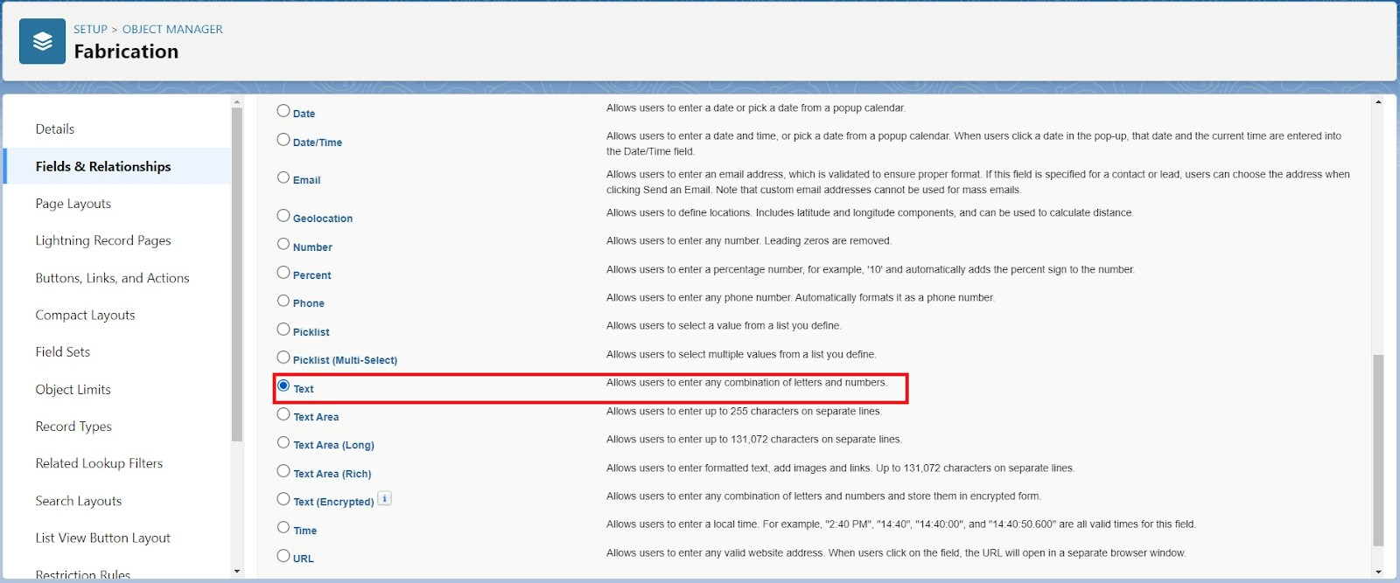

8. Milestone 7 – Roll-up Summary
Roll-up summaries on Player include Matches Played, Number of 50’s, Number of 100’s, Total 4’s, Total 6’s, Total Runs, Total Overs, Total Wickets, Total Stumpings and Total Catches.
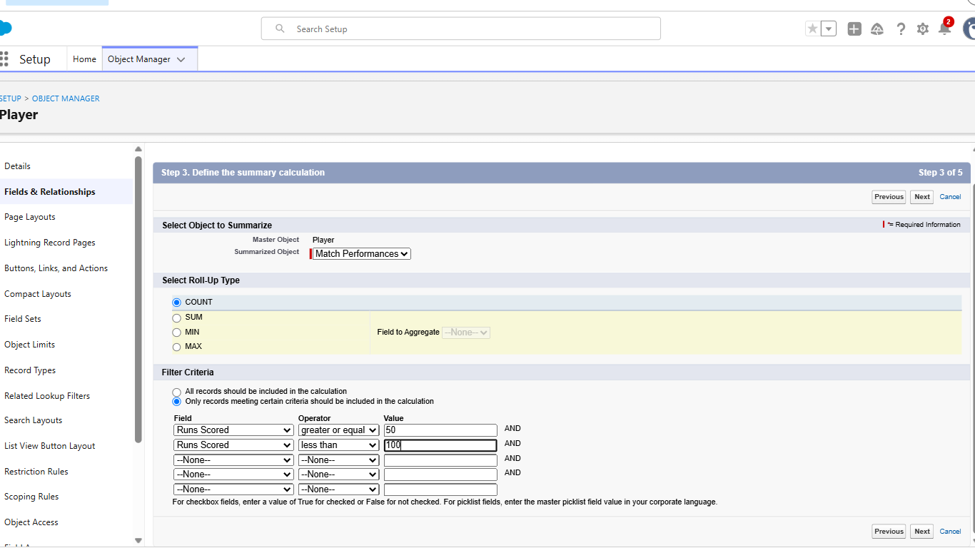

9. Milestone 8 – Flows
Create a Screen Flow named Player Flow. The flow uses a Team picklist, retrieves Player records by Team and displays a data table with Profile Picture, Player Name, Total Runs, AVG Score, Batting Style, Bowling Style, Matches Played, Number of 50’s and Number of 100’s. Add the flow to the CRICKSTATS Home Page and activate it.

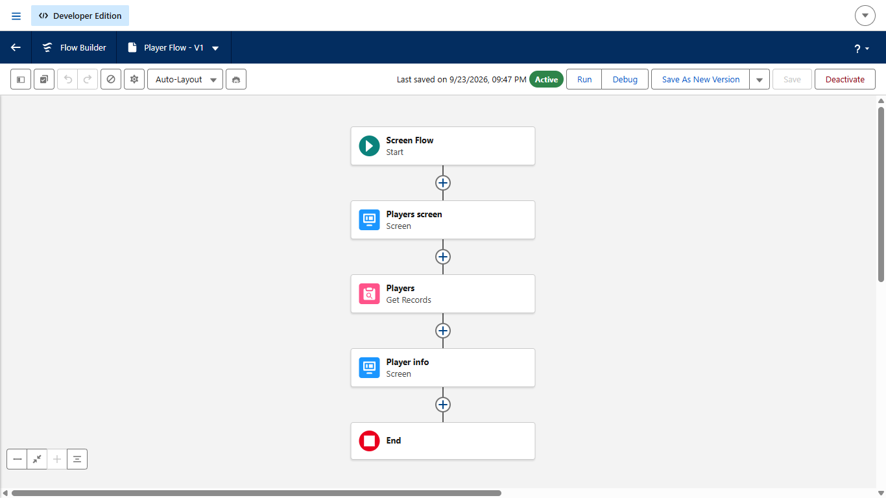

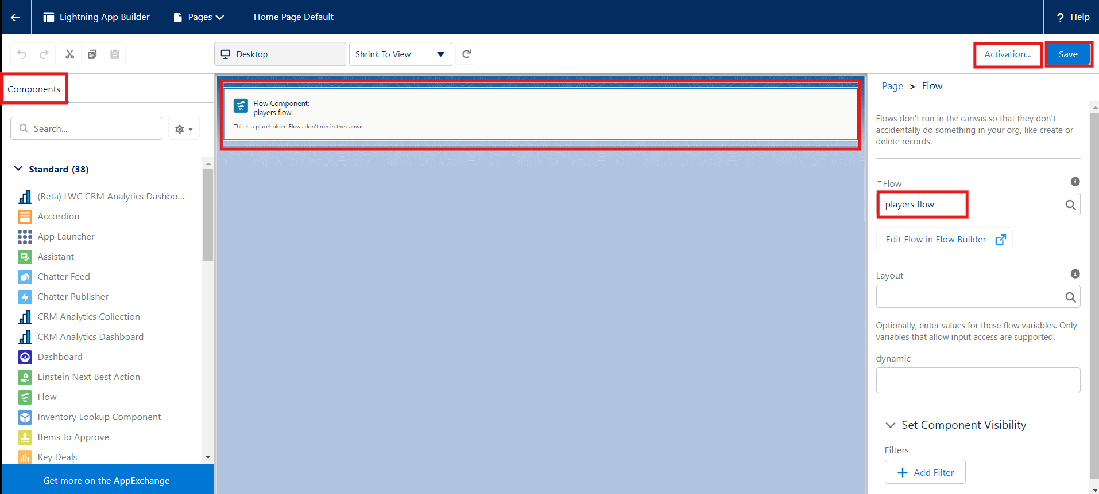

10. Phase Conclusion
The development phase implements the CRICKSTATS Salesforce application through custom objects, tabs, Lightning App configuration, fields, relationships, roll-up summaries and flows.

